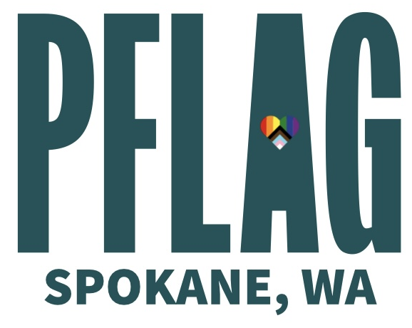

Helen Bonser Memorial Scholarship

PFLAG Spokane’s mission is leading with love to create a caring and affirming world for LGBTQ+ people and those who love them. The annual scholarship honors the legacy of Helen Bonser who founded the PFLAG Spokane chapter.

Scholarship eligibility requirements:
- 2.0 minimum GPA.
- Must be a resident of Washington state.
- Identify as gay, lesbian, bisexual, transgender, intersex, queer or straight ally.
- LGBTQ+ continuing higher education or full-time undergraduate student or student attending or planning to attend vocational/Trade school.
- Must be at least eighteen years of age.
- Applicants must demonstrate a financial need.
- Members of the board of directors and reigning title holders are ineligible to apply.

Process:
- Applications must be received by May 20th, 2026
- Applications may be submitted by email to: admin@pflag-spokane.org
- Additional pages for comments/explanations may be attached to this application.
- Scholarship recipient’s will be announced at the PFLAG pride step down on May 30th, 2026.
- Recipients will be notified by phone.
- Applicants understand that the scholarship funds will be paid directly to the college, university, vocational tech, or trade school.

Applicant
Name: Date:
Address:
City: State:
Email: Phone:

Name of College, University, Technical, or Trade School:

Field of Study:
Current Grade Level: Current GPA:
Degree Goal:
Expected Graduation Date:

Please Tell us About Yourself:

Career Goal:

Tell us your knowledge of the LGBTQ+ Community:

Tell us about any special circumstances you feel PFLAG should be aware of:

For Office use Only
Application Number______________

